**CODING ASSESSMENT – 21-07-2025**

USE burger_bash;

**TABLES**

**1.burger_names**

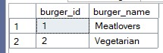

**2.burger_runner**

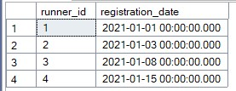

**3.customer_orders**

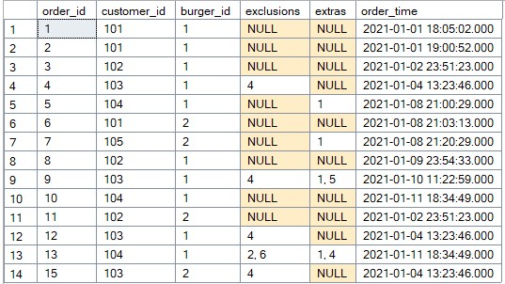

**4.burger_runner_orders**

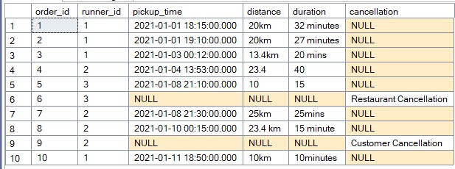

**-- 1. Total Revenue Generated per Runner**

SELECT

r.runner_id,

SUM(CASE WHEN bro.distance LIKE '%km%'

THEN CAST(REPLACE(bro.distance, 'km', '') AS FLOAT) * 1.5 -- Assume €1.5/km

ELSE CAST(bro.distance AS FLOAT) * 1.5 END) AS revenue

FROM burger_runner_orders bro

JOIN burger_runner r ON bro.runner_id = r.runner_id

WHERE bro.cancellation IS NULL

GROUP BY r.runner_id;

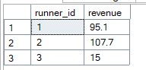

**-- 2. Average Delivery Time per Runner (Minutes)**

SELECT

runner_id,

AVG(CAST(SUBSTRING(duration, 1, PATINDEX('%[^0-9]%', duration + 'x') - 1) AS INT)) AS avg_delivery_time_minutes

FROM burger_runner_orders

WHERE cancellation IS NULL AND duration IS NOT NULL

GROUP BY runner_id;

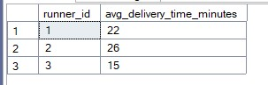

**-- 3. Most Popular Burger with Exclusions/Extras**

SELECT TOP 1

b.burger_name,

COUNT(*) AS customized_orders_count

FROM customer_orders co

JOIN burger_names b ON co.burger_id = b.burger_id

WHERE co.exclusions IS NOT NULL OR co.extras IS NOT NULL

GROUP BY b.burger_name

ORDER BY customized_orders_count DESC;



**--4. Percentage of Cancelled Orders by Cause**

SELECT

cancellation,

COUNT(*) AS cancellation_count,

ROUND(COUNT(*) * 100.0 / (SELECT COUNT(*) FROM burger_runner_orders), 2) AS percentage

FROM burger_runner_orders

WHERE cancellation IS NOT NULL

GROUP BY cancellation;

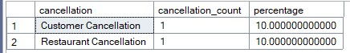

**--5. Customer Order Frequency Analysis**

SELECT

customer_id,

COUNT(*) AS order_count,

DENSE_RANK() OVER (ORDER BY COUNT(*) DESC) AS customer_rank

FROM customer_orders

GROUP BY customer_id;

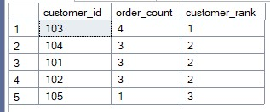

**--6. Runner Efficiency by Order Volume & Distance**

SELECT

bro.runner_id,

COUNT(bro.order_id) AS completed_orders,

SUM(CAST(REPLACE(REPLACE(bro.distance, 'km', ''), ' ', '') AS FLOAT)) AS total_distance_km,

SUM(CAST(REPLACE(REPLACE(bro.distance, 'km', ''), ' ', '') AS FLOAT)) / COUNT(bro.order_id) AS avg_distance_per_order

FROM burger_runner_orders bro

WHERE bro.cancellation IS NULL

GROUP BY bro.runner_id

ORDER BY completed_orders DESC;

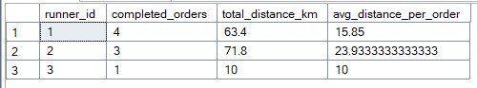

**--7. Minimum Delivery Time (Fastest Order)**

SELECT

MIN(CAST(SUBSTRING(duration, 1, PATINDEX('%[^0-9]%', duration + 'x') - 1) AS INT)) AS min_delivery_time_minutes

FROM burger_runner_orders

WHERE cancellation IS NULL AND duration IS NOT NULL;



**--8. Maximum Distance Covered for Successful Deliveries**

SELECT

MAX(CAST(REPLACE(REPLACE(distance, 'km', ''), ' ', '') AS FLOAT)) AS max_distance_km

FROM burger_runner_orders

WHERE cancellation IS NULL AND distance IS NOT NULL;



**--9. Runner with Minimum Deliveries (WHERE + Aggregate)**

SELECT TOP 1

runner_id,

COUNT(order_id) AS deliveries

FROM burger_runner_orders

WHERE cancellation IS NULL

GROUP BY runner_id

ORDER BY deliveries ASC;

SELECT * FROM customer_orders;

